Expertise objets ethno Vanikoro

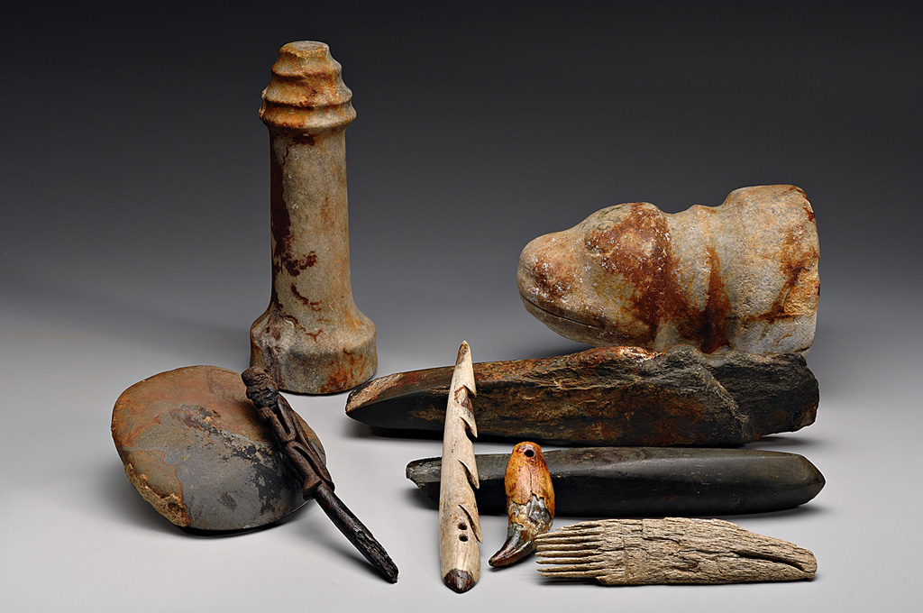
> Dear Thierry
> Thank you for your letter and the photograph of these artifacts.
> They are amazing and are almost all identifiable. In terms of dating,
> they would all have been in use during the 1700s and earlier and so
> are part of the general assemblage of Northwest Coast technologies
> found widely throughout the area.
> I will show them to my team of researchers in the Laboratory of
> Archaeology here at UBC and they can, hopefully, match them up with
> their database. Within the next year or two we hope to have our
> database on-line and searchable so this is something that will be
> easily done by anyone. But, until then, we can compare them with know
> materials in our collections.
> The basic assemblage in the photo is:
> one hand maul with concentric grooves (back, standing)
> one stone axe head or chopper (lower left)
> one anthropomorphic blanket pin (wood or bone?) (this looks like it
> could be Coast Salish) one unilateral harpoon head (possibly antler)
> one tooth pendant (grizzly or sea lion?)
> two nephrite or greenstone adze blades (large one in back is unfinished)
> one bone or antler comb (front right)
> one large zoomorphic hammerstone/pounder (perhaps a club head or a stake
> pounder)--(rear, right).
>
> I will forward this photo and your email to our team leader and ask if
> we might be able to help with something more specific.
>
> Fascinating discoveries indeed! Thanks for bringing them to our
> attention.
>
> Sincerely
> Michael Blake
>
>
> On Dec 11, 2007 8:36 AM, <Thierry.Boyer@pc.gc.ca> wrote:
>
>
> Hi, I found your email addresses on the University of British Columbia
> website.
>
> An underwater archaeologist colleague from France, Elisabeth Veyrat,
> has asked us for some help, since we are more likely to have some West
> Coast archaeology contacts. She wishes to identify some artifacts
> from wrecks she has excavated belonging to the La Pérouse global
> explorations of
> (1785-1788) (see Wikipedia under Jean-François de Galaup, comte de La
> Pérouse). The wrecks are located on the tiny and remote island of Vanikoro
> in the Salomon Islands. Evidently, prior to the wrecking, when the
> explorers coasted along the northwest coast of North America they gathered
> local items. Élisabeth is currrently putting together an exhibit about the
> expedition in Le Musée de la Marine in Paris, France. Could you have a look
> at the attached photos and give some ideas as to general identification,
> provenance and date, or point us in the direction of a contact (in Canada
> or Alaska) who might be able to assist?
> Many thanks,
>
> Thierry Boyer
> Archéologue sous-marin/Marine Archaeologist
> Agence Parcs Canada/Parks Canada Agency
> 1800 Walkley Road
> Ottawa (Ontario)
> K1A 0M5
> (613) 993-2125 #211
> fax/télécopieur: (613) 993-9796
> thierry.boyer@pc.gc.ca
>
>
>
> (See attached file: vanikoro images.pdf)
>
> (See attached file: assemblage vanikoro.jpg)
>
> --
> Michael Blake
> Department of Anthropology
> University of British Columbia
> 6303 N.W. Marine Drive,
> Vancouver, B.C. Canada V6T 1Z1
> phn: 604-822-3124
>

