- 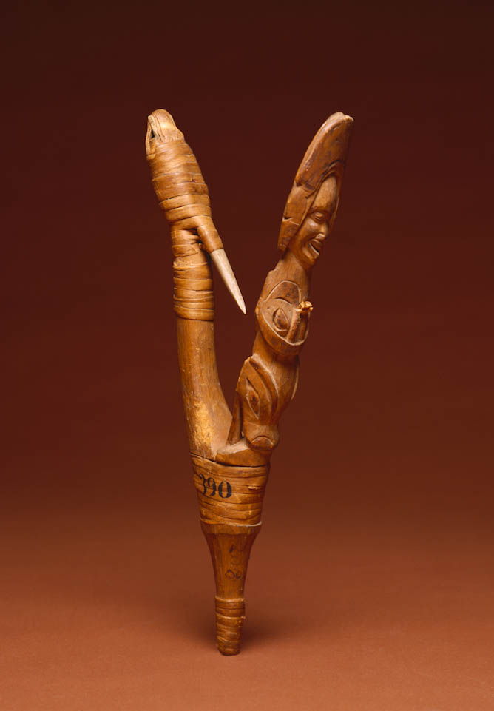 Probably Tlingit artist
- Fishhook, about 1800
- Wood, bone, spruce root
- Alaska, Pacific Northwest Coast, United States
- L: 8 7/8 in, W: 5 1/2 in, D: 2 in (L: 22.5 cm, W: 14.0 cm, D: 5.1 cm)
- Gift of Clifford Crowninshield and Mayhew Folger, 1802
- E3548
- Made to catch halibut, one of the largest fishes in the North Pacific Ocean
- Usually carved by the fisherman, and imbued with supernatural powers to help with the catch
This V-shaped fishhook is comprised of two wooden arms lashed together; a bone barb is attached to one, and the fisherman's spirit helpers are on the other. On this hook, a human, with a spiny sculpin (fish) on his head, stands on top of a sea creature.

